A

Project Report

On

**7 BEST AUTOMOTIVE TECHNOLOGIES**

**OF 2019**

*Submitted in partial fulfillment of*

*The requirement for the diploma of*

**Computer Engineering**

**Submitted by**

1)Piyush chavan(52)

2)Pratik Sarkate(45) 3)Abhinav Hadole(60)

4)Tanmay Tiwari(47)

**Under the Guidance of**

**Prof. Swati. Tayede**

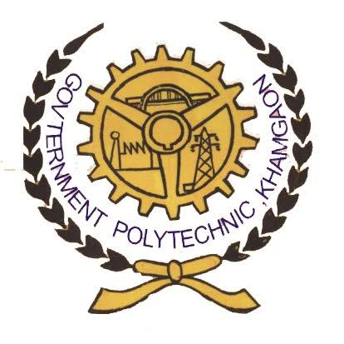

##### Department of Computer Engineering

Government Polytechnic, Khamgaon

**2018-19**



Department of Computer Engineering

Government Polytechnic, khamgaon

**Certificate**

*The project report entitled “****7 BEST AUTOMOTIVE TECHNOLOGIES OF 2019”*** *is a bonafide work carried out in Second semester in a partial fulfillment of the requirements for diploma in computer engineering from Government Polytechnic, Khamgaon during the academic year 2018-19.*

**SUBMITTED BY**

1)Piyush chavan(52)

2) Pratik Sarkate (45)

3) Abhinav Hadole (60)

4) Tanmay Tiwari(47)

Signature: Prof. Swati.Tayade

Date:

**Acknowledgement**

The real spirit of achieving a goal is through the way of excellence and lustrous discipline. I would have never succeeded in completing my task without the cooperation, encouragement and help provided to me by various personalities.

First of all we would like to thank our principal Dr.S.S.Prabhune, who provided with the necessary facilities and advice. We are also thankful to Prof. S.H. Bailmare Madam, Head of Computer Department for this valuable suggestions and support. With great pleasure we are really thankful to guide Prof. Swati.Tayade for her valuable suggestions, support and sincere guidance for the completion of this project.

Also I would like to thanks to all teaching and non-teaching staff of the department for their encouragement, cooperation and help. My greatest thanks are to all who wished me success especially my parents, my friends whose support and care makes me stay on earth.

**Submitted By**

1)Piyush chavan(52)

2) Pratik Sarkate (45)

3) Abhinav Hadole (60)

4) Tanmay Tiwari(47)

**Index**

* + - 1. **Introduction**

1) 7 BEST AUTOMOTIVE TECHNOLOGIES OF 2019

**2. Topics**

2.1 CONNECTER MOBILE APP

2.2 TENN DRIVING TECHNOLOGY

2.3 STOLEN VEHICLE TRACKING SOFTWARE

2.4 ADAPTIVE CRUISE CONTROL

2.5 EXIT WARNING TO PROTECT CYCLIST

2.6 LANE DEPARTURE WARNING

2.7 AUTOMATIC EMERGENCY BREAKIG

**Introduction**

In today’s world we can see many technologies are growing day by day. But we mostly know technology related mobile , laptop etc. But we are also growing up with automotive technologies like we can connect mobile to car . We can also protect our car by thiefsby using tracking devices and software . Many people don’t follow the lane because while driving car they can’t see outside to follow lane so for that there are also some technology we are going to see it in detail